Little SPARK: Simple Play Adaptations to Reference for Kids

Social Story Book by Carol Gray
Description: | Image:
This book features stories that help modify behavior and teach life skills with visual prompt-pictures that make the stories even more effective. | 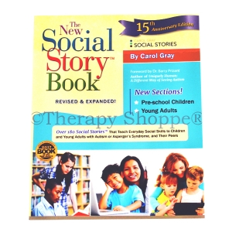

Who Might Benefit?
Those who have difficulty with social interaction, anxiety, behavioral regulation, sensory processing, and adapting to change often thrive with structured routines and targeted support.

Why Use?
Provides an opportunity to build self-regulation, make positive behavior choices, understand social situations, and feel prepared for new experiences through predictable routines and clear expectations.
Instructions for Use: | Adaptation Ideas:
Environmental Considerations  - Use in the environment they are intended for.  Basic Play/Use  - Introduce before the situation/event occurs.  Extended Play/Use  - Review the story following targeted situations and discuss outcomes.  Play/Use with Others  - Designed to be used individually for targeted behaviors but could be used in whole groups to form class expectations. | Simplify It  - Use short sentences at the child’s level of understanding.  Add Sensory Cues  - Use video or digital formats as alternatives to paper/text.  Communication Support  - Add picture symbols, photographs, or the child’s drawings.  Alternative Uses  - Use to teach self-care routines and task completion.

Words to Encourage Play/Use
Read  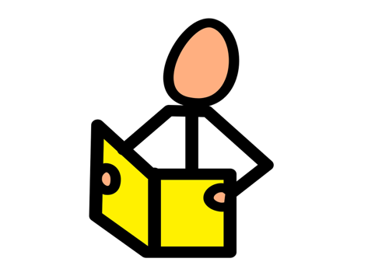 | Listen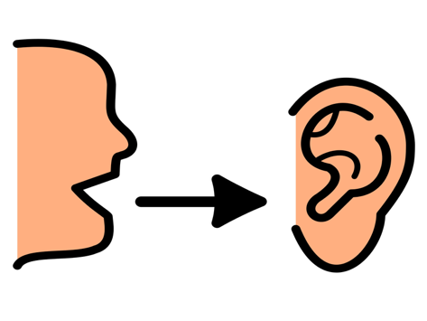 | Sit
Look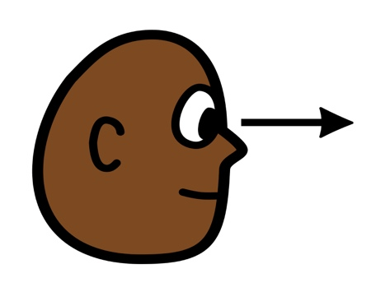 | Turn | Help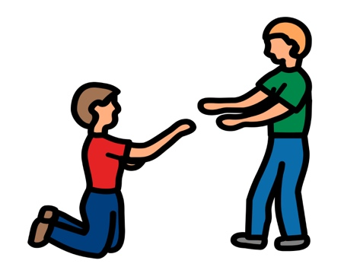
Next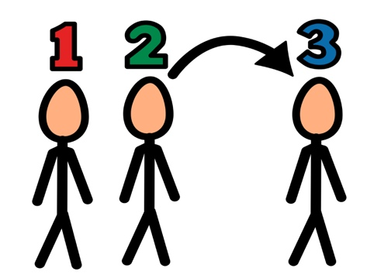 | Ready | Done
*”Adaptations” adapted from: Haugen’s Modes for Adapting Toys based on materials from the "Let's Play" Project at the University of Buffalo
PCS is a trademark of Tobii Dynavox, LLC. All rights reserved. Used with permission.

